ML Project Report: Loan Risk Prediction

Team Members
- Jayant Sharma - IMT2023523
- Akshat Betala - IMT2023019
- Avancha Dedeepya - IMT2023006
Github Link : https://github.com/Akshat089/ML-project-2

Task
Training ML models to predict loan default risk is fundamentally a binary classification problem, where the target variable is the RiskFlag. Unlike the previous regression task, here we aim to categorize applicants into two distinct classes: those likely to default (1) and those who are not (0). Several factors contribute to this assessment—ranging from financial history and income to demographic details—making this task a matter of estimating the probability of default based on an applicant's profile.

Dataset and Features Description
Predicting borrower risk is the backbone of the banking and fintech sectors. Accurate risk modeling ensures financial institutions can minimize losses while maximizing loan approvals for viable candidates. This dataset provides a robust profile of loan applicants, enabling the development of models to automate credit decision making.

Data Fields
Here is a description of the features found in the dataset:
- ProfileID | Unique identifier assigned to each applicant profile.
- ApplicantYears | Age of the applicant (in years).
- AnnualEarnings | Applicant’s annual income, representing financial stability.
- RequestedSum | Total loan amount requested by the applicant.
- TrustMetric | Credit score of the applicant, indicating financial trustworthiness.
- WorkDuration | Total number of months the applicant has been employed.
- ActiveAccounts | Number of active credit lines or financial accounts held by the applicant.
- OfferRate | Interest rate offered for the applicant’s requested loan.
- RepayPeriod | Duration of the loan repayment period (in months).
- DebtFactor | Debt-to-Income (DTI) ratio, reflecting financial burden.
- QualificationLevel | Highest educational qualification attained by the applicant.
- WorkCategory | Type of employment (e.g., salaried, self-employed, contractual).
- RelationshipStatus | Marital status of the applicant.
- OwnsProperty | Indicates if the applicant owns property (1 = Yes, 0 = No).
- FamilyObligation | Indicates if the applicant has dependents or family responsibilities.
- FundUseCase | Purpose or reason for taking the loan (e.g., education, medical, business).
- JointApplicant | Specifies whether the loan application includes a co-signer or co-applicant.
- RiskFlag | Target variable — 1 if the applicant is likely to default, 0 otherwise.

EDA and pre-processing
The following section outlines the necessary steps for conducting essential Exploratory Data Analysis (EDA) to gain insights, detect potential issues, and prepare data for model training.

1. Import Libraries and Load Dataset
The initial step in the process involves importing essential libraries such as pandas, numpy, matplotlib, seaborn, and relevant modules from scikit-learn for data preprocessing and modeling. The train.csv and test.csv datasets are loaded into pandas DataFrames, and their shapes are printed to confirm the initial dimensions.

2. Data Overview
A basic structural overview of both datasets was performed using:
- .shape
- .info()
- .head()
This ensured the dataset was correctly loaded and provided initial insight into variable types and sample data.

3. EDA & Target Variable Analysis
The RiskFlag column was analyzed using value counts to observe class distribution.
This helped identify whether the dataset was balanced or imbalanced, directly impacting model selection and evaluation strategy.

4. Handling Missing Values

A global safety cleanup was implemented to handle data irregularities:
- Infinite Values: Mathematical operations (like division by zero in feature engineering) could produce infinity. These were replaced with NaN.
- Imputation: We used Median imputation or all missing values.

5. Handling Duplicate Values
While handling duplicates is a common preprocessing step, this specific pipeline does not include an explicit step for dropping duplicate rows. The focus is instead directed toward comprehensive feature engineering and missing value imputation.

6. Feature Engineering
To capture financial stress patterns and improve linear separability, four domain-specific interaction features were engineered:
Feature Name | Formula | Purpose
LoanToIncome | RequestedSum / (AnnualEarnings + 1) | Measures financial burden
IncomePerAccount | AnnualEarnings / (ActiveAccounts + 1) | Income distribution check
EMI_Burden | RequestedSum / (RepayPeriod + 1) | EMI pressure estimation
DebtStress | DebtFactor * RequestedSum | Debt intensity calculation

7. Categorical Feature Encoding
A two-part encoding strategy was used:
Encoding Type | Columns Used
Binary Encoding | OwnsProperty, FamilyObligation, JointApplicant
One-Hot Encoding | QualificationLevel, WorkCategory, RelationshipStatus, FundUseCase
To prevent unseen category issues, train and test were combined before encoding and split again afterward.

Highly skewed features were transformed using log1p for improved model performance:

8. Exploratory Data Analysis (EDA)
Multiple visualizations were performed to understand the dataset:
🔹 Distribution Plots
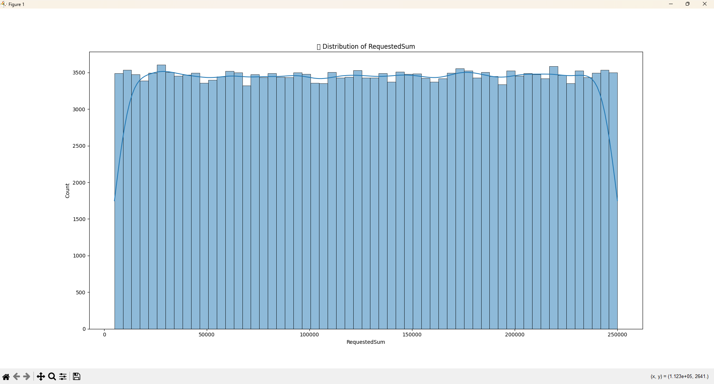
🔹 Boxplots (Outlier Detection)
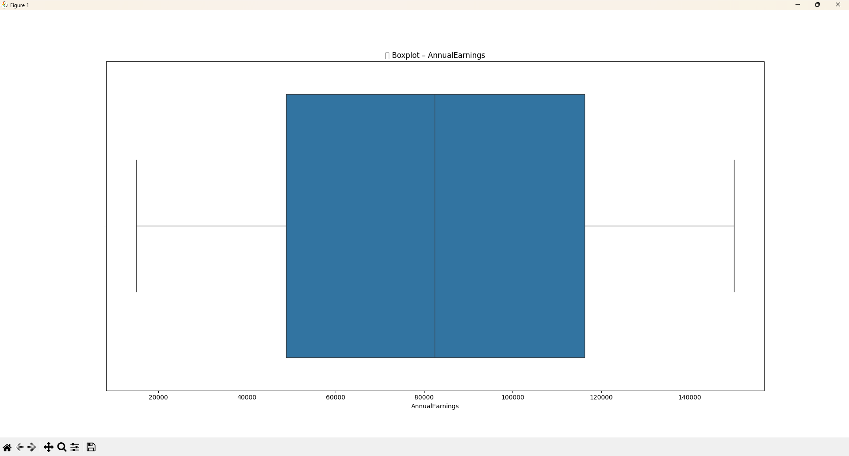

🔹 Correlation Heatmap
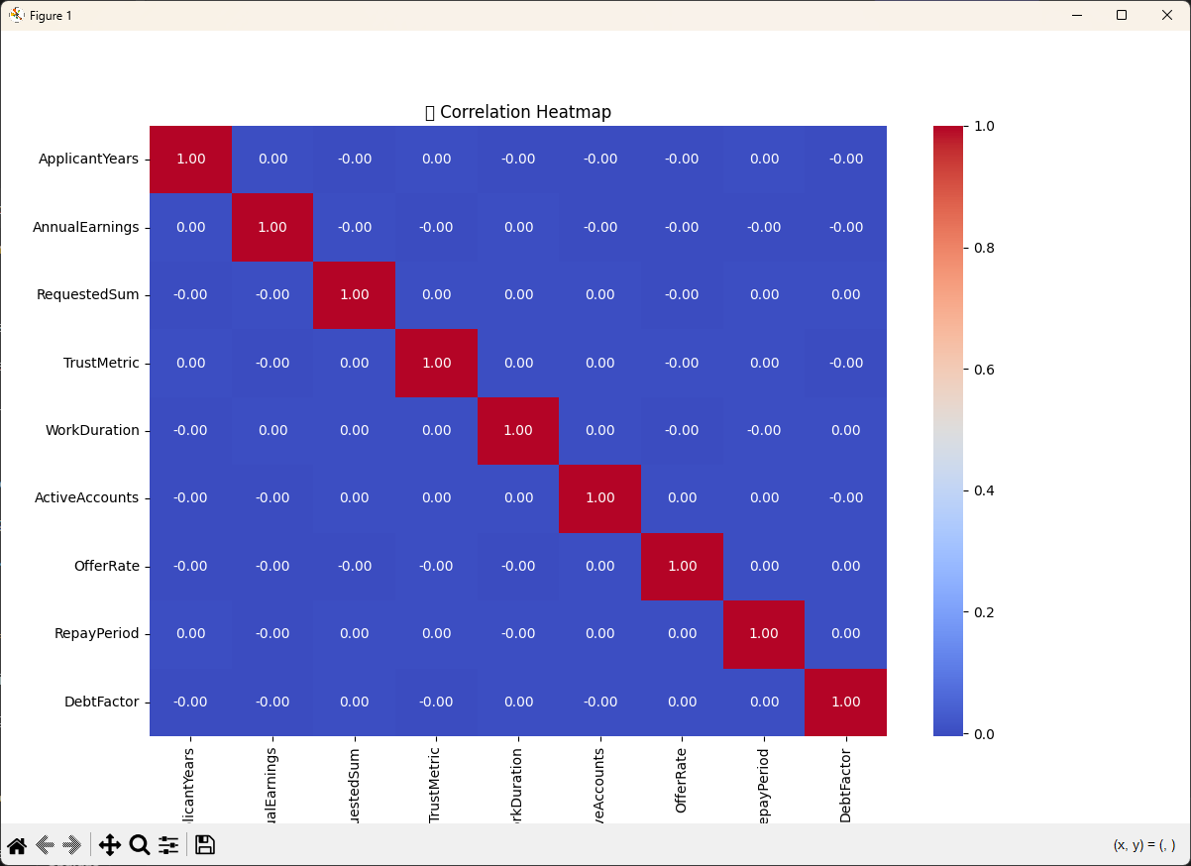

🔹 Categorical vs Target Distribution
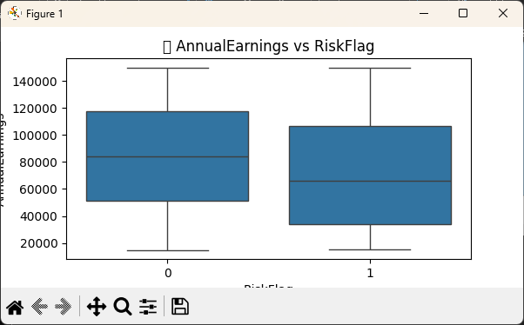

These visual insights helped determine:
✔ feature importance
✔ outliers
✔ skewed distributions
✔ variable interactions

9. Model Training and Validation

Two SVM experiments were conducted:
Model | Training Data Used | Purpose
SVM (20% data) | Quick testing | Faster training
SVM (100% data) | Final model | Higher accuracy

A train-test split was NOT used — instead:
✔ Cross-validation (K-Fold) was preferred
✔ Final predictions were generated using full training data

Models Used for Training

1. Logistic Regression
- We applied the same preprocessing steps outlined in the previous section, including StandardScaler for numeric features and One-Hot Encoding for categorical variables.
- We utilized C=0.01 (strong L2 regularization), solver='lbfgs', and max_iter=3000 to ensure convergence. Crucially, we used class_weight='balanced' to address the dataset's imbalance between defaulters and non-defaulters.
- This model achieved a score of 0.724.
- While it provided a stable baseline, the lower score compared to other models suggests that the relationship between borrower attributes and risk is not purely linear in a probabilistic sense, or that the model was too constrained by the regularization.

2. Support Vector Machine (LinearSVC)
- Standard scaling was critical here as SVMs are distance-based algorithms.
- We used LinearSVC with C=0.1, dual=False (preferred when n_samples > n_features), and max_iter=5000.
- This was the best performing model, achieving a score of 0.884.
- The superiority of the Linear SVM suggests that in the high-dimensional space created by One-Hot Encoding, the decision boundary between risky and safe borrowers is a distinct hyperplane. The C=0.1 parameter provided a wider margin, allowing for better generalization than the Logistic Regression.

3. XGBoost Classifier
- Included the same feature engineering pipeline.
- We tuned the model with n_estimators=500, learning_rate=0.05 (for slower, more robust learning), max_depth=7 (to capture deeper interactions), and scale_pos_weight to handle class imbalance.
- The model achieved a score of 0.738
- Surprisingly, the tree-based ensemble performed significantly worse than the SVM. This indicates that the dataset might not benefit from the complex, non-linear hierarchical splits that XGBoost offers, or that the model struggled to separate the noise from the signal despite the specific hyperparameters.

4. Neural Network

- Standard scaling and categorical encoding were used.
- The model was trained over several epochs monitoring Train Loss vs. Val Loss. We utilized Early Stopping (triggered around Epoch 15) to prevent overfitting.
- This model achieved a strong score of 0.826, placing it second.
- The training logs indicate the model converged quickly (Val Loss stabilized ~1.038). While it outperformed the tree-based models and Logistic Regression, it could not beat the crisp decision boundary found by the SVM.

Interesting Observations
1. The Unexpected Dominance of SVM
The most striking finding is that LinearSVC (0.884) outperformed both the probabilistic Logistic Regression (0.724) and the advanced XGBoost (0.738) by a wide margin. This suggests that while the data is high-dimensional (due to dummy variables), the classes are linearly separable if the correct margin is found. It highlights that "newer" or "more complex" models (like Gradient Boosting) are not always better for every dataset.
2. Failure of Tree-Based Models
In many tabular competitions, XGBoost is the gold standard. However, here it scored 0.738, significantly lower than the SVM. This might indicate that the feature space is sparse (due to many categorical variables) which can sometimes make it harder for trees to find split points compared to a linear model that looks at the global vector space.
3. Neural Network as a Strong Contender
The Neural Network performed surprisingly well (0.826), bridging the gap between the linear models. The training logs showed that the validation loss plateaued very quickly (around epoch 5), indicating that the signal in the data is strong but limited—the model learned everything it could very fast, and further training yielded diminishing returns.
4. Impact of Class Weighting
Across all models (Logistic, XGBoost, SVM), explicitly handling the class imbalance was non-negotiable. In Logistic Regression, we used class_weight='balanced', and in XGBoost, we used scale_pos_weight. Without these parameters, the models would likely have defaulted to predicting "No Risk" for everyone to maximize accuracy while failing the F1/AUC metrics.
5. Regularization Sensitivity
The difference between Logistic Regression (C=0.01) and SVM (C=0.1) is notable. The SVM allowed for a "softer" margin (lower C means more regularization in SVM terms, but 0.1 is relatively standard), whereas the Logistic Regression with 0.01 might have been under-fitting slightly, unable to capture the nuances that the SVM's geometric approach could.
References:
- https://scikit-learn.org/stable/modules/svm.html (For Support Vector Machines)
- https://xgboost.readthedocs.io/en/stable/ (For XGBoost Documentation)
- https://scikit-learn.org/stable/modules/linear_model.html (For Logistic Regression)
- https://pandas.pydata.org/pandas-docs/stable/user_guide/missing_data.html (For Missing Data handling)
- https://www.geeksforgeeks.org/log-transformation-for-skewed-data/ (For Data Normalization)

